GENAI STUDIO PLATFORM

- MODEL ON-BOARDING CONFIGURATION

Overview: The Model On-boarding module acts as the primary gateway and governance checkpoint for introducing new artificial intelligence capabilities into the GenAI Studio Platform. Whether integrating ultra-large parameter foundational models (LLMs), highly targeted embeddings for Retrieval-Augmented Generation (RAG), or generative image models, this module ensures every endpoint is cataloged, restricted by cost controls, and vetted before being exposed to developers and agents in the ecosystem.

  - Model On-boarding Dashboard

The dashboard serves as the central command center for model administration. It provides a real-time, high-density view of the entire AI portfolio attached to the platform.

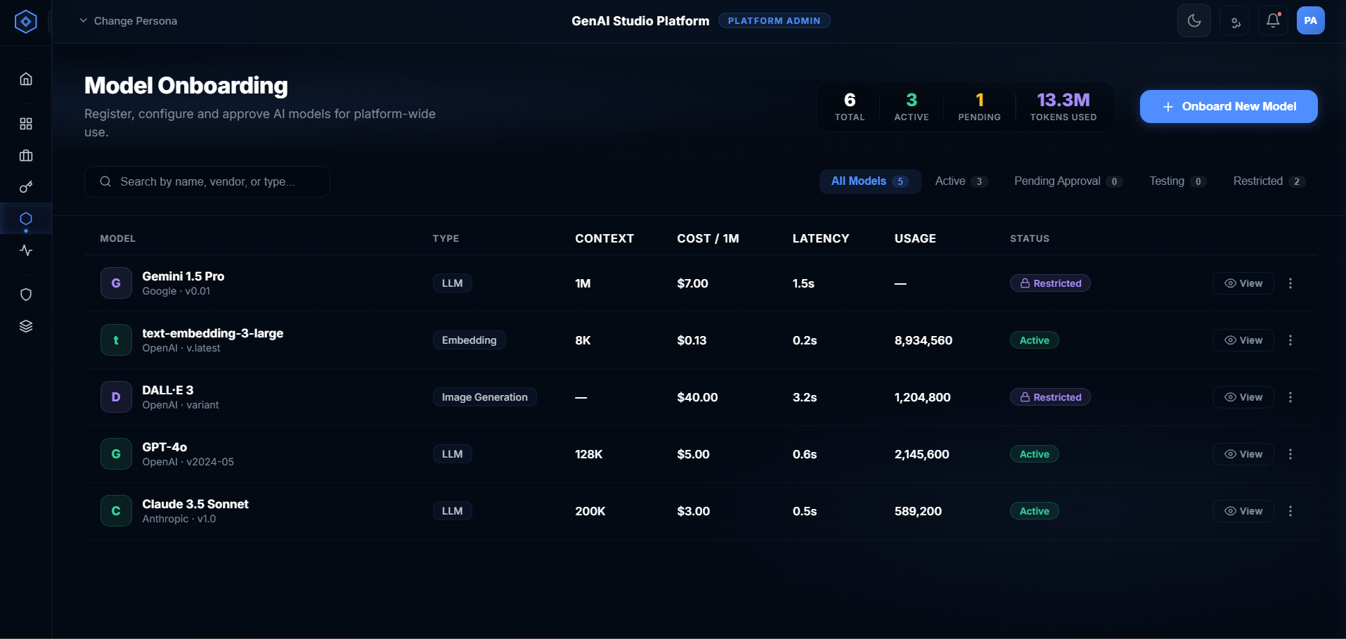

1.1.1 Top-Level Key Performance Indicators
At the top of the interface, four critical dials provide instantaneous platform health and scale metrics:

- Total Models: The absolute count of all model profiles created in the system, regardless of their current operational state.
- Active: The subset of models that have passed all compliance checks and are currently routing live traffic.
- Pending: Models that are drafted or currently awaiting secondary approvals from the Governance or Compliance teams.
- Tokens Used: A cumulative, real-time counter of total platform tokens consumed (measured in Millions/Billions) across all Active models.

1.1.2 The Telemetry Data Grid
The on-boarding process is triggered via the "+ Onboard New Model" action, initiating a strict 3-stage configuration sequence wrapped in a modal drawer.

- Model Identity Array: Displays the human-readable name, the provider (e.g., OpenAI, Meta, Google), and the specific version tag (e.g., v2024-05).
- Type Classification: Denotes if the model is an LLM, Embedding, or Image Generation engine.
- Context Capacity: Defines the maximum token window (e.g., 8K, 128K, 1M, 2M) the model can hold in memory per transaction.
- Cost Density (Cost / 1M Tokens): Evaluated cost per one million blended input/output tokens. Used heavily by the prompt router to find the most cost-effective model for a given task.
- Median Latency: A rolling average (measured in seconds) of the time-to-first-token (TTFT) or total response time.
- Aggregate Usage: Raw token volume processed by this endpoint since its onboarding date.
- Status Badge: A color-coded marker (Green/Warning/Gray/Purple) denoting the exact availability state of the endpoint.

  - The Deep-Dive On-boarding Workflow

The on-boarding process is triggered via the "+ Onboard New Model" action, initiating a strict 3-stage configuration sequence wrapped in a modal drawer.

Stage 1: Core Metadata & Capabilities Identification
This stage establishes the model's identity, physical location, and fundamental boundaries.

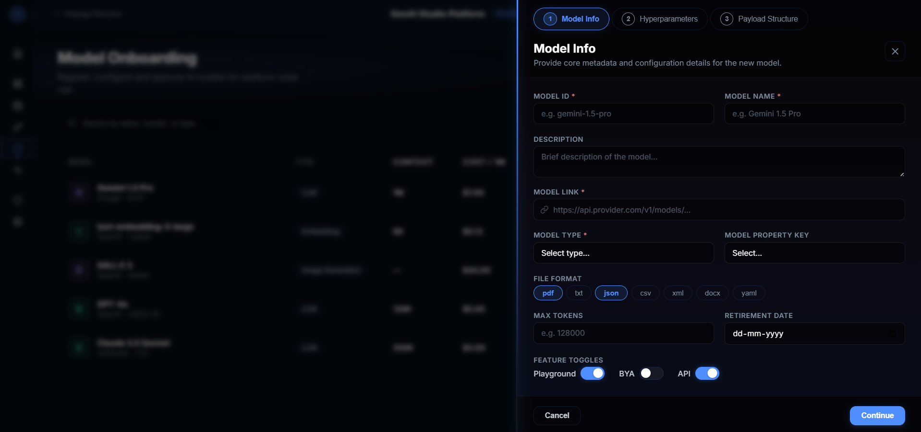

- Model ID: The exact programmatic string required by the API (e.g., gpt-4-turbo-preview). This must precisely match the vendor's documentation.
- Model Name: The friendly label exposed to end-users and developers in the Playground dropdowns (e.g., GPT-4 Turbo).
- Description Markdown: A comprehensive summary outlining the model's strengths (e.g., "Excellent for aggressive code refactoring and logical reasoning. Weak at creative writing.").
- Model Link (URI): The exact secure endpoint. For external models, this is the vendor's API URL. For internally hosted models, this is the VPC/Kubernetes service address.
- Type Assignment: Determines which UI components and routing logic the model supports.
- Property Key Assignment: Maps the model to a specific organizational billing or cost-center bucket.
- File Format Parsing Limits: Explicitly defines which documents the model natively supports for extraction (e.g., restricting a basic LLM to TXT and JSON, while allowing a multimodal LLM to accept PDF and DOCX).
- Absolute Max Tokens: The hard ceiling on tokens. Even if a user requests 128K tokens, if this is set to 32K, the platform gateway will truncate the request to protect budgets.
- Retirement/Deprecation Date: A proactive calendar setting. Once this date is reached, the model automatically shifts to Restricted status to prevent reliance on deprecated vendor APIs.
- Feature Toggles:
  - Playground: If enabled, the model is visible in the human-in-the-loop chat UI.
  - BYA (Build Your App): If enabled, AI agents can autonomously invoke this model during complex planning loops.
  - API: If disabled, programmatic API keys cannot route requests to this endpoint.

Stage 2: Hyperparameter Guardrails & Threshold Boundaries
This crucial stage defines the minimums, maximums, and default behaviors for parameter tuning. By setting strict boundaries here, administrators prevent developers from accidentally generating unstable outputs or consuming excessive compute.

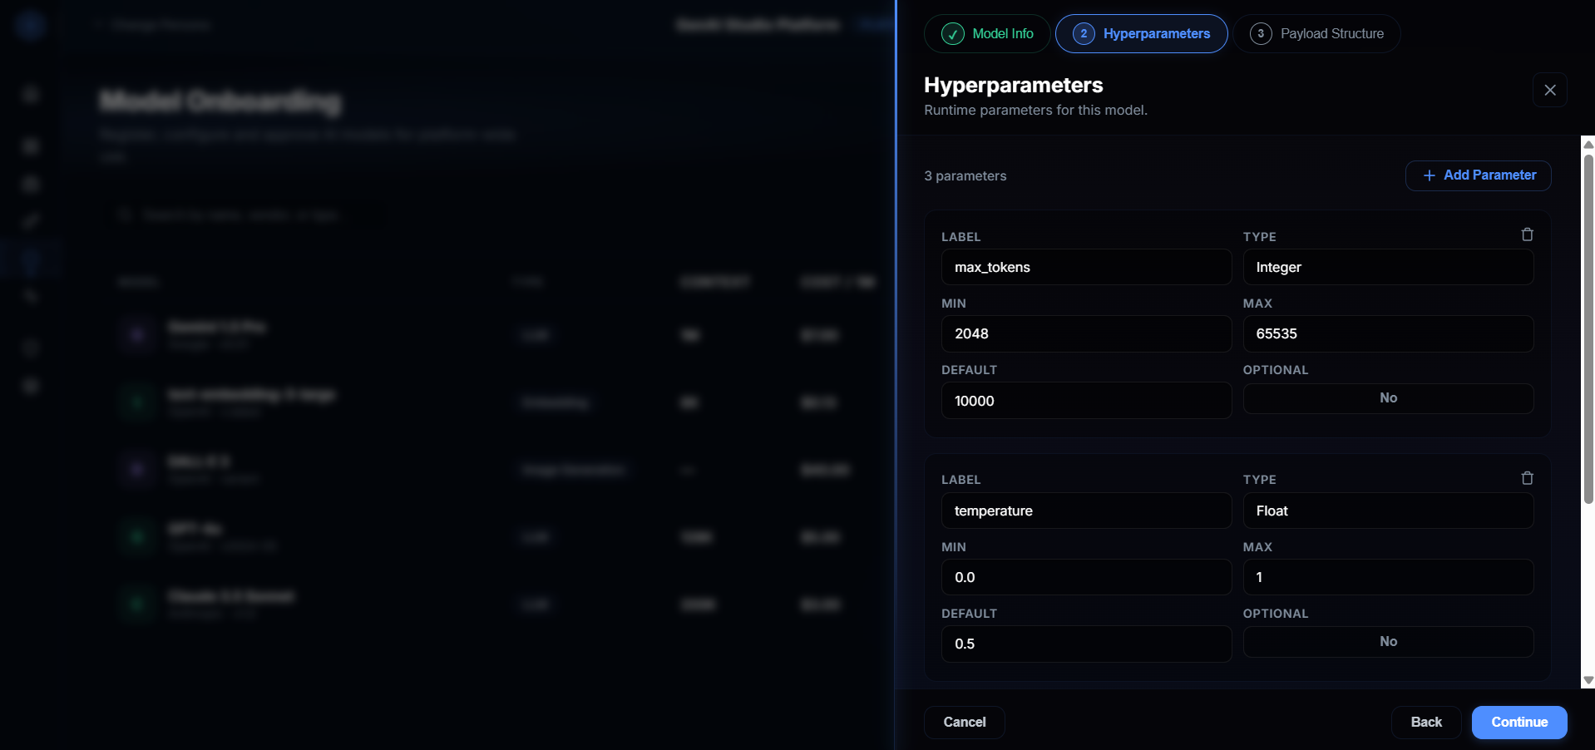

Every hyper parameter can be registered with the following rigid constraints:
- Label: The exact JSON key expected by the model (e.g., temperature, top_p, presence_penalty, frequency_penalty).
- Data Type Enforcement: Ensures that an input like temperature is strictly evaluated as a Float, while max_tokens is evaluated as an Integer.
- Min/Max Boundary Box:
  - Example: Setting temperature Min to 0.0 and Max to 1.2. If a user attempts to pass a temperature of 1.5, the platform gateway will intercept and reject the API call with a 400 Bad Request before it ever reaches the vendor.
- System Default: The fallback value injected into the payload if the user or agent does not explicitly define it.
- Optionality Flag: If set to "Required", payload validation will fail if this exact parameter is missing from an incoming API request.

Stage 3: Payload Structure Mapping
Allows custom JSON template mapping so that internally hosted, non-standard models can adapt to the platform's standardized API specification.

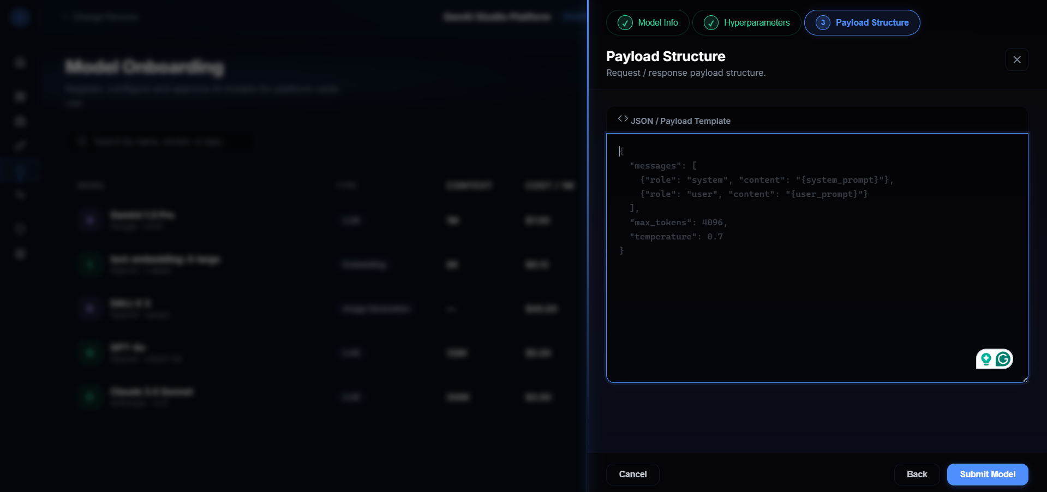

- Model Evaluation, Auditing & Telemetry

Overview: The Model Evaluation module is a dedicated environment within GenAI Studio allowing administrators and AI engineers to run batch tests against specific models. Users can upload bulk prompts (CSV/Excel) and context documents, configure runtime parameters, and generate an evaluation report containing quality scores, latency, and token consumption metrics.

  - Setting Up an Evaluation Run

The evaluation setup is divided into an intuitive "bento box" card layout on the main dashboard.

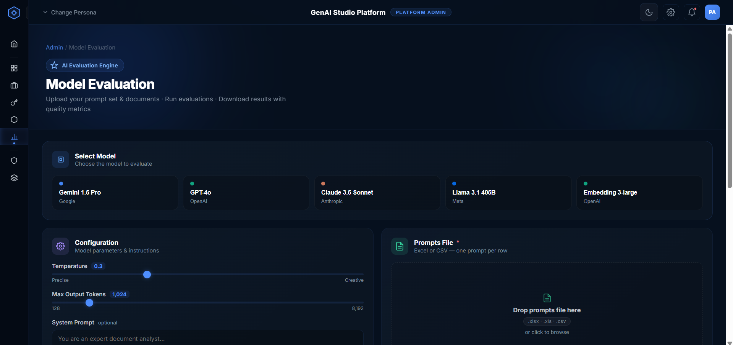

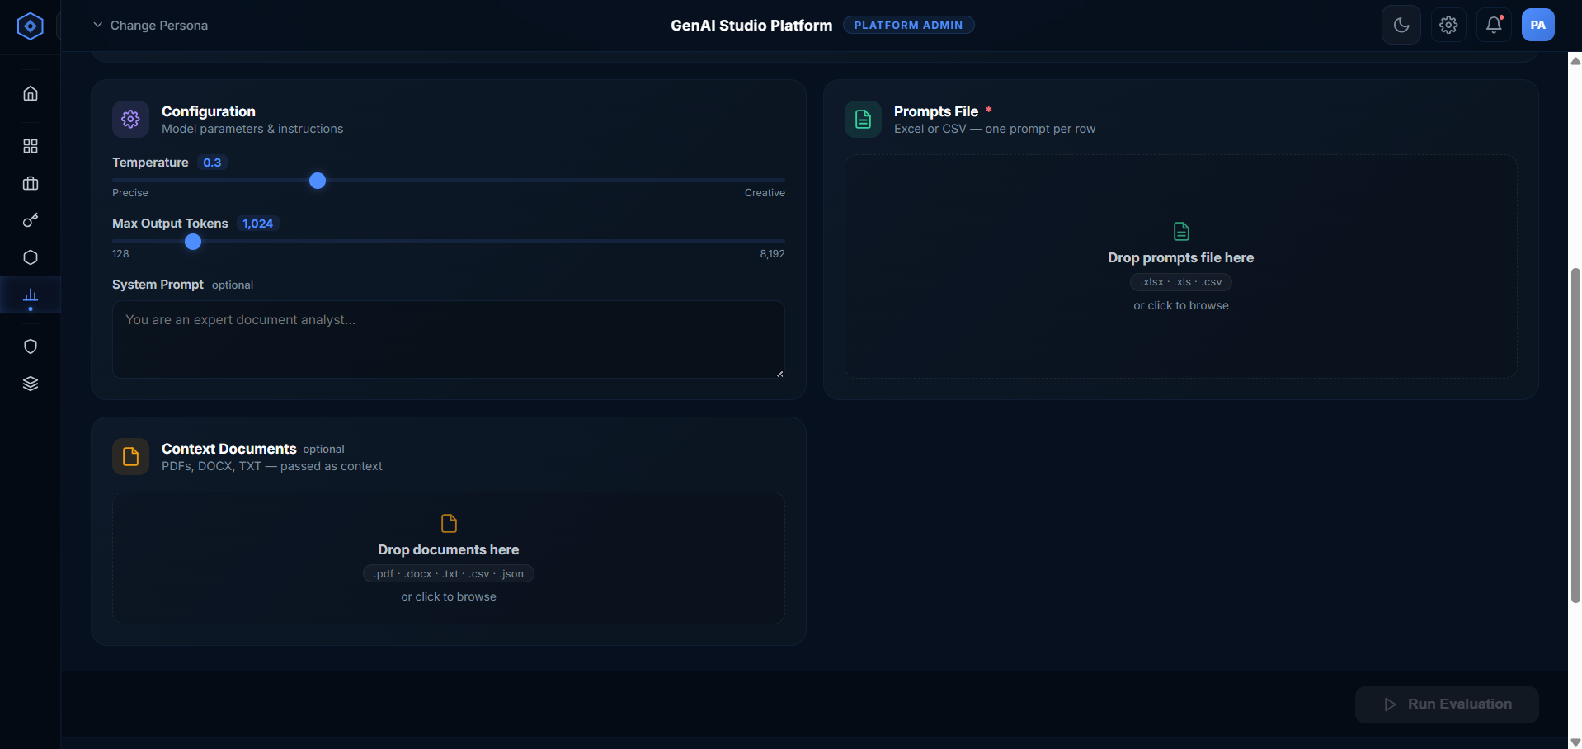

    - Model Selection
- Model Picker: Administrators select a target model (e.g., GPT-4o, Claude 3.5 Sonnet, Llama 3.1 405B) from the active catalog to evaluate.
    - Configuration Parameters
- Temperature Slider: Controls the randomness of the output (range: 0.0 to 1.0, shifting from Precise to Creative).
- Max Output Tokens Slider: Sets the hard limit on the length of the generated response (range: 128 to 8,192).
- System Prompt: An optional text area to inject a foundational system instruction (e.g., "You are an expert document analyst") applied to all prompts in the batch.
    - Data Uploads (Drop Zones)
- Prompts File (Required): A drag-and-drop zone accepting .xlsx, .xls, or .csv files. The system expects one prompt per row.
- Context Documents (Optional): A drag-and-drop zone accepting .pdf, .docx, .txt, .csv, .json, .xml files to provide background context for the evaluation.

  - Running and Exporting Evaluations
Once the setup is complete, the Run Bar at the bottom of the setup section summarizes the selected configuration (Model, Prompt File, Document count) and provides the primary "Run Evaluation" action.

During the run, a progress bar tracks the batch completion status. Once finished, an "Export Results (.csv)" button becomes available in both the hero section and the Run Bar to download the raw data.

  - Evaluation Results & Analysis
After an evaluation completes, the "Results" section surfaces three distinct analytical views (Tabs), allowing administrators to drill down from high-level metrics to specific prompt outputs.

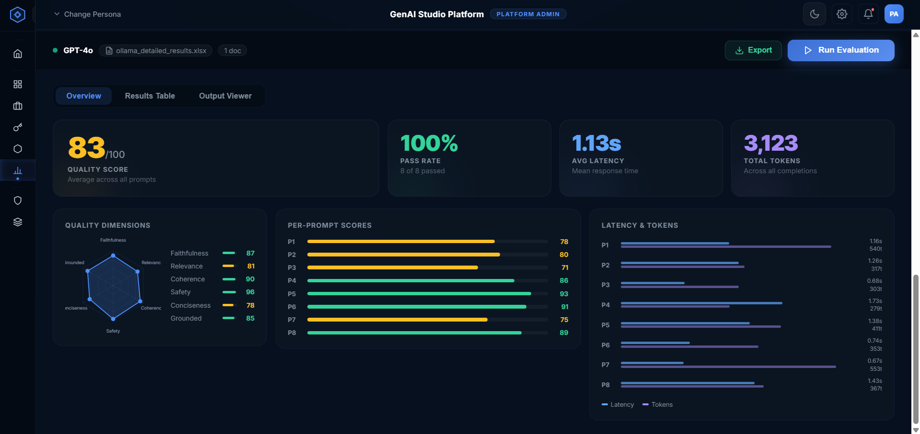

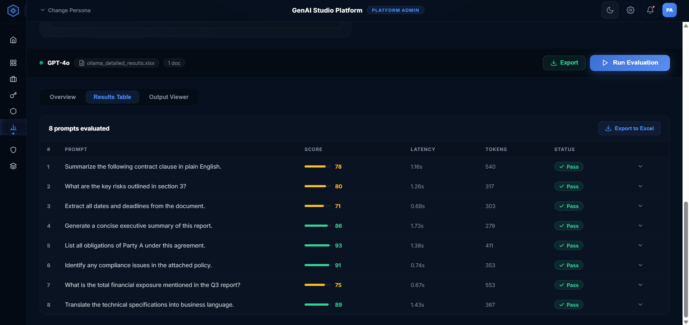

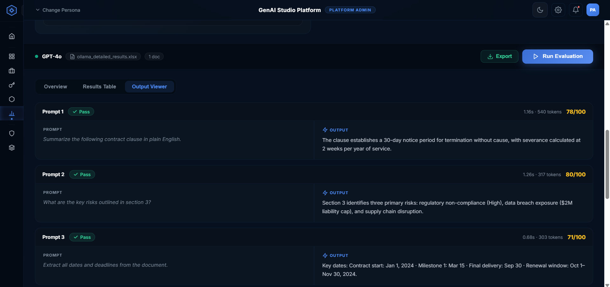

    - Overview Tab
The Overview dashboard provides immediate, visual insights into the batch performance.
- Top-Level KPI Cards: Quality Score: An aggregate score (0-100) averaged across all prompts.
- Pass Rate: The percentage of prompts that achieved a passing status.
- Avg Latency: The mean response time across the batch in seconds.
- Total Tokens: The aggregate token consumption (input + output).
- Quality Dimensions (Radar Chart): A breakdown of the overall score across specific heuristic dimensions (Faithfulness, Relevance, Coherence, Safety, Conciseness, Groundedness).
- Per-Prompt Scores: A horizontal bar chart displaying the individual quality score assigned to each prompt ID in the batch.
- Latency & Tokens Chart: A comparative visual separating the time cost (Latency) from the processing cost (Tokens) for every prompt.

1.3.2 Results Table Tab
A dense, data-rich table designed for detailed sorting and triage.
- Columns: Prompt ID, Prompt snippet, Quality Score (with visual bar), Latency, Tokens, and Status Badge (Pass/Review).
- Expandable Rows: Clicking the chevron on any row expands it to reveal the full, un-truncated Prompt text and the complete Model Output side-by-side.
- Includes a dedicated "Export to Excel" button scoped specifically to the table data.

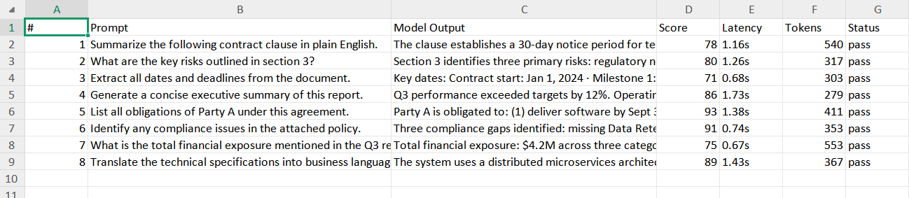

    - Output Viewer Tab
A focused, reading-optimized layout.
- Each prompt is displayed as an individual card.
- The header contains the status badge, transaction metrics (latency/tokens), and the final quality score.
- The body presents the user's Prompt and the Model's Output in a clean, split-column interface, making it easy to quickly review the subjective quality of the generative text.

